Hadoop

Hadoop Version
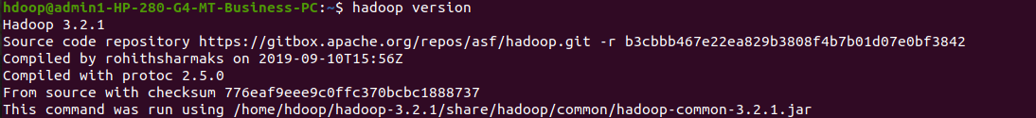
start -dfs.sh

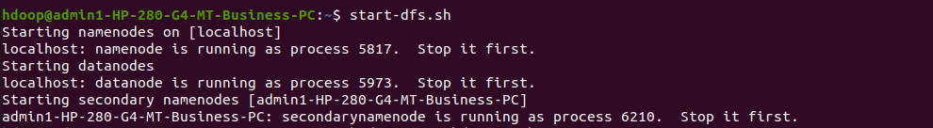
Creating a directory

hadoop fs -mkdir /snehaa
This creates directory with name snehaa

Listing all files in directory
hadoop fs -ls /

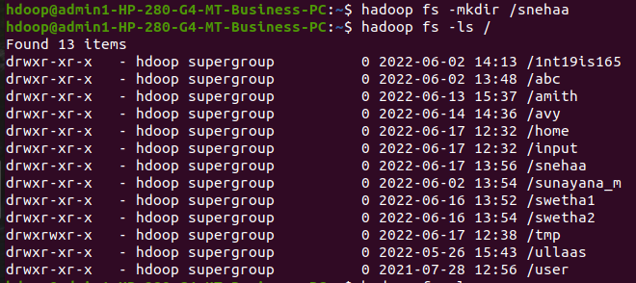

Adding a sample file to directory and list it using command

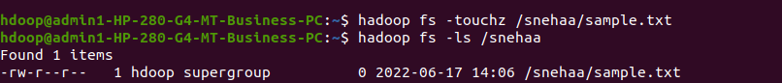
Creating directory inside another directory

hadoop fs -mkdir /snehaa/1NT20IS414
hadoop fs -ls /snehaa
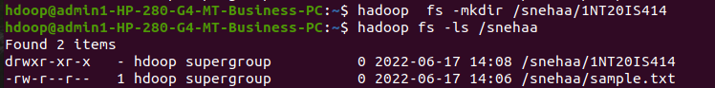
Creating a file in local system and giving a text to be placed in system

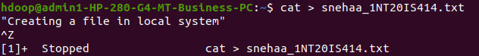
Creating a file inside nested directory

hadoop fs -touchz /snehaa/1NT20IS414/sample2.txt
hadoop fs -ls /snehaa/1NT20IS414

copying files from hdfs to local sysyem

hadoop fs -copyToLocal /snehaa/1NT20IS414/sample2.txt

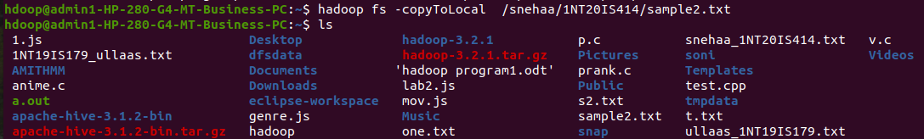

use mv command to move files from local sysytem and hdfs file system

hadoop fs -mv /snehaa/sample.txt /snehaa/1NT20IS414
hadoop fs -ls /snehaa/1NT20IS414

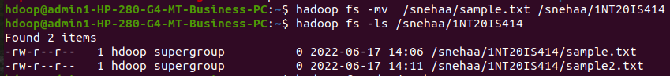
To display size of all files in the directory

hadoop fs -du /snehaa
hadoop fs -du -s /snehaa

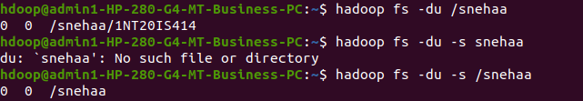

To append one file to another file
hadoop fs -appendToFile one.txt /snehaa/1NT20IS414/sample2.txt
hadoop fs -cat /snehaa/1NT20IS414/sample2.txt
Here one.txt has been created and that file is been appened to sample2.txt

